**Experiment - 4**

**Aim: To add Links and Lists to HTML Web Page**

Links : HTML Links / Hyperlinks

The <a> tag defines a hyperlink, which is used to link from one page to another.

The most important attribute of the <a> element is the href attribute, which indicates the link's destination.

By default, links will appear as follows in all browsers:

* An unvisited link is underlined and blue
* A visited link is underlined and purple
* An active link is underlined and red

<a href="./index.html">Home</a>

List :

1 . Unordered List

* The <ul> tag defines an unordered (bulleted) list.
* Use the <ul> tag together with the <li> tag to create unordered lists.

<ul>

<li>Coffee</li>

<li>Tea</li>

<li>Milk</li>

</ul>

Output:

* Coffee
* Tea
* Milk

2 . Ordered List

* The <ol> tag defines an ordered list. An ordered list can be numerical or alphabetical.
* Use the <ol> tag together with the <li> tag to create ordered lists.

<ol>

<li>Coffee</li>

<li>Tea</li>

<li>Milk</li>

</ol>

Output:

1. Coffee

2. Tea

3. Milk

**Outputs**

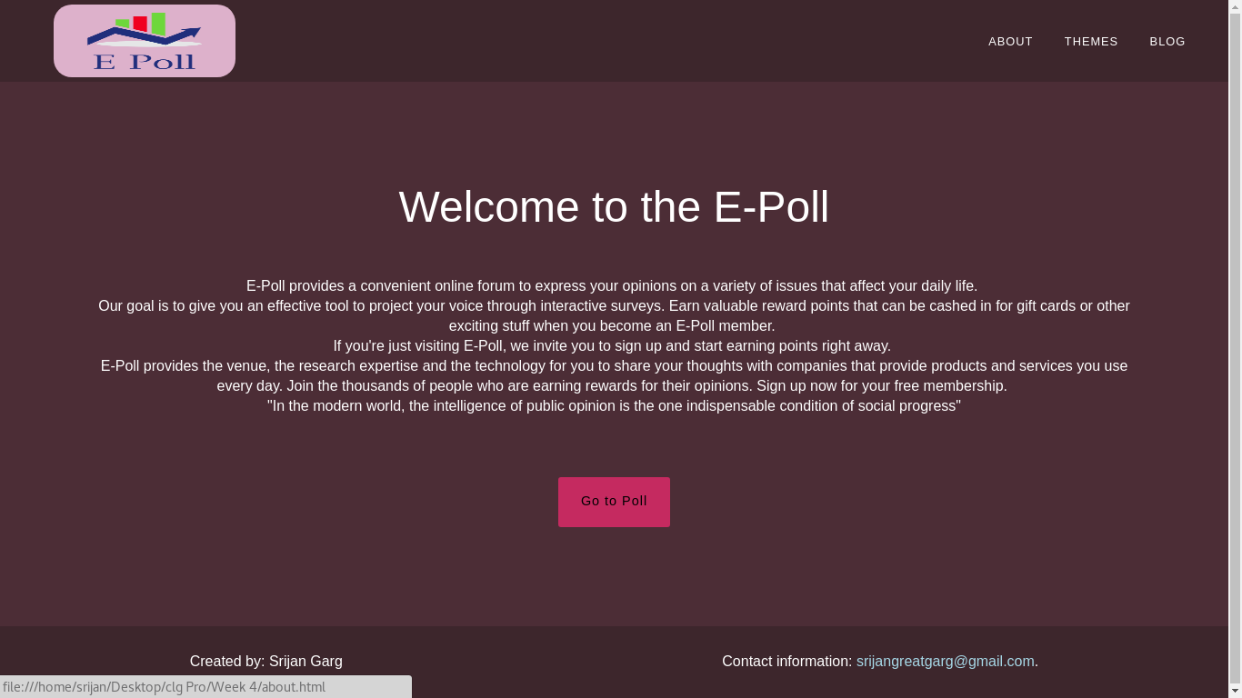

**Navigation in Menu Bar**

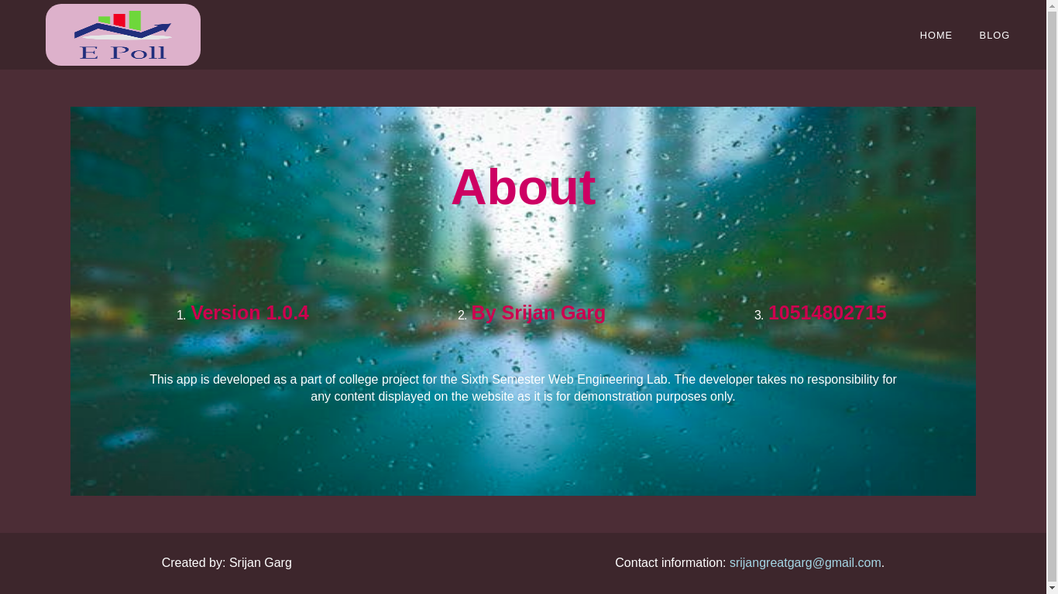

**Ordered List and Navigation**



**Navigation and List in Menu Bar**